Doc Writer: Raghavendra Dasari Doc Date: Jan 12, 2015.

Application or System Name
PrePay ENROLLMENT CENTER
General Overview
The PrePay program is being designed to provide the customer with the option to pay in advance for the energy they intend to consume. The benefits are founded on the premise that customers will have more control over energy bills and consumption. PrePay provides customers “real time” or “up-to-date” metrics on their energy usage, and balances, allowing customers to pay at their convenience.
Enrollment/De-Enrollment Screen – The screen will display and allow the CSR to enroll/de-enroll a customer. The screen will show eligibility, PayGo link, and enroll/de-enroll button.
Eligibility Check - In order to ensure that customers are eligible for PrePay Enrollment, a new ruleset for eligibility rules will be built in BRF+ (similar to the existing DPP and DLA Eligibility checks designed in BRF+). This new set of eligibility rules will be called when the CSR initiates the PrePayment screen.
Scripting – Once the CSR clicks the enroll button, Terms and Conditions page will be displayed. The CSR will need to read the scripting to the customer and will require their agreement. Based on the customer’s agreement to the terms and conditions the customer will be able to enroll or de-enroll in the PrePayment program.
Contact Data - Data is required from the customer to be able to enroll in PrePay. Enrollment email is required to send the enrollment confirmation to the customer. The customer will also have to provide a preferred email, text, or phone and a critical email, text or phone to receive their notifications.
Enrollment - Once the eligibility is met, and the enroll button is selected; an existing customer will have a new contract and contract account created upon a new move-in completed. If it’s a new customer, without an invoice, the customer will use the newly created contract.
De-Enrollment - A customer can de-enroll from the program upon request or from a move-out. If the customer calls in for a De-enrollment the customer will be returned to a post pay customer but no change in contract account is needed. If a customer moves-out then the CSR will follow the normal move-out procedure.
CSR Alert - The CE CSR’s need to be alerted to the customer’s participation in the PrePay program. This will be displayed as an alert for the various stages of enrollment. When enrollment is initiated it will display “PrePay Enrollment Pending,” once the PrePay enrollment is completed and confirmed by PayGo the alert will display “PrePay Program Participant.” Upon De-enrollment from the program the alert will be removed.
Interaction Records - If customers call into the Consumers Energy call center and ask questions related to their PrePay participation and its impacts, the CE CSRs need to have a basic understanding of the customer’s participation in PrePay. To enable the CSRs, Interaction Records will be logged into system at various touchpoints, including enrollment and de-enrollment.
PayGo Link - Once the customer is enrolled into PrePay the CSR will need to have the ability to look at their account in realtime. This will be achieved through the PayGo website, which will hold the current balance remaining on their account. The CSR will be able to select the PayGo link in CRM to open the PayGo Portal.
An enhancement is needed in CRM to cover various Programs Enrollment Processes and sub processes in regards to how the enrollment and de-enrollment is initiated and completed in SAP. Alternative to this object is to, The CE user would have to remember themselves to initiate Enrollment request for the customer, manually investigate to identify if the account is considered eligible for Enrollment.
If implemented, CSRs will be able to easily identify customer program eligibility for the programs included in the Enrollment Center. Customer Program Enrollment and De-Enrollment will be initiated will be consistent for all programs included in the Enrollment Center.
Enrollment Center screen has four main component
- Participating program
- Available program
- Eligibility Messages
- Program History
Before displaying the enrollment center, Eligibility check is performed on the programs to check whether the programs are eligible or not.
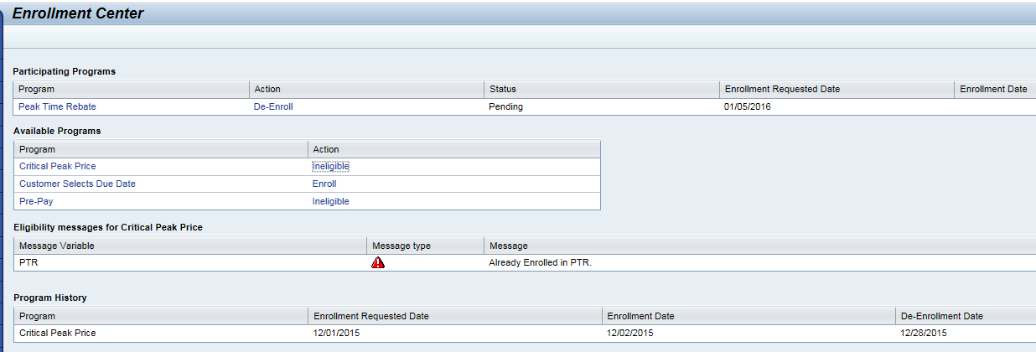
By implementing this solution the CE CSRs will require minimal effort in enrolling/de-enrolling a customer into PrePay program. They will also achieve greater visability into the customer’s program participation.
Technical Design:
Function Modules:
ENHANCEMENT DESIGN SPECIFICATIONS:
Enhancement Requirements
Number | Description of Requirement
1 | Creation of new Function Module to check the basic eligibility checks for the respective programs.
2 | Creation of System Message in CRM prompting Customer Program Enrollment and Navigation to Enrollment Center.
3 | Creation of Enrollment Center component to show the CSR with the enrolled/eligible programs along with the eligibility messages and also the program history.

- CRM PrePay Enrollment/De-enollment Screen. (Includes Enroll/De-enroll button, Enrollment status, Reasons why enrollment is not possible, Contact fields and Scripting) Interaction Record and Contact creation during enrollment/ De Enrollment.
- PrePay option will be offered during a move-in if the customers meet the eligibility criteria.
- CSR will have ability to add customer to PrePay program any time.
- PrePay customers must supply 1 out of 3 of the following communication channels. Communication channel types may be the same as long as the end-point is different (2 different e-mail addresses, 2 different phone numbers, etc..):
-E-mail account
-Text Messaging Number
-Phone Number (voice enabled)
Customer will identify a preferred communication channel for all PrePay Notices
Customer must also identify a critical communication channel (which must be different than preferred) for 2 day, 1 day, $0 balance and disconnect notice.
Enhancement Requirements
Number | Description of Requirement
1. | When user select Agree button from PrePay terms and conditions, contact data popup will display with contact data fields and text.
2 | Enrollment Confirmation email will prepopulate the email field if customer has an email on file.  BP table But021_fs – Pull Address number AD_ADDRNUM  Address number table ADR6 – Pull email AD_SMTPADR
3 | Perferred and Critical Text and Voice fields will prepopulate when the voice or text radio button is slected.  BP table But021_fs – Pull Address number AD_ADDRNUM  Address number table ADCP – Pull Telephone AD_TLNMBR1
4 | Email radio button will pull the email from the enrollment confirmation to auto populate the email preferred or critical fields.
5 | Submit button will trigger the enrollment in ECC.
6 | Cancel button will close the screen and no changes will occur in the system.
7 | Once the submit button is clicked, trigger custom event for enrollment using  Business object; ZISUACCNT  Event; zppmenroll
8 | List of parameters for custom event ZISUACCNT and zppmenroll  Parameters;  EnrollmentReqDate (default system date)  EMailAddress (take from contact screen)  PreferredCommMethod (take from contact screen)  PreferredCommChannel (take from contact screen)  CriticalCommMethod (take from contact screen)  CriticalCommChannel (take from contact screen)  CreatedBy (default system user)
9 | Using the below Function Module validate the email address format is valid.  lv_email_adr-type = 'INT'.  lv_email_adr-address = <but051>-smtp_address.  call function 'SX_INTERNET_ADDRESS_TO_NORMAL'  exporting  address_unstruct = lv_email_adr  exceptions  error_address_type = 1  error_address = 2  error_group_address = 3  others = 99.
10 | To validate the Phone Number format CHAR LENGTH = 10 or 12 (depending on Business rule)  l_c_allowed_chars TYPE char30 VALUE '0123456789-',  l_c_allowed_nums TYPE char30 VALUE '0123456789',
Enhancement Requirements
Number | Description of Requirement
1. | Create a Z-Class ZCL_CRM_IC_F_G_PPM: Use CL_CRM_IC_F_G_BA as Superclass.
2 | Implement Interface method IF_CRM_SMF_SERVICE~EXECUTE, to process/return the following ICRULE attributes:  - ZPPM_PENDING  - ZPPM_CANCELED  - ZPPM_COMPLETED  - ZPPM_DEENROLL
3 | ZPPM_PENDING is set to “X” if:  The confirmed account has an entry in the PrePay Enrollment table (ZTPGM_ENROLL) and the status is = to ‘Pending’.  The above check is performed for the confirmed BA, and will query the PrePay Enrollment Table as stated.
4 | ZPPM_CANCELED is set to “X” if:  The confirmed account has an entry in the PrePay Enrollment table (ZTPGM_ENROLL) and the status is = to ‘Canceled’.  The above check is performed for the confirmed BA, and will query the PrePay Enrollment Table as stated.
5 | ZPPM_COMPLETED is set to “X” if:  The confirmed account has an entry in the PrePay Enrollment table (ZTPGM_ENROLL) and the status is = to ‘Enrolled’.  The above check is performed for the confirmed BA, and will query the PrePay Enrollment Table as stated.
6 | ZPPM_DEENROLL is set to “X” if:  The confirmed account has an entry in the PrePay Enrollment table (ZTPGM_ENROLL) and the status is = to ‘De-Enrolled’.  The above check is performed for the confirmed BA, and will query the PrePay Enrollment Table as stated.
7 | The Alerts are triggered for the following IC Events: BuAgConfirmed. The event is defined within the Rule Policy ZPPM_ALERTS.
1. | Use existing RFC-enabled FM Z_SE_IR_CREATE which was created under FG Z_SMARTENERGY to create interaction records for PrePay as well.  This function module has below input parameters:  I_BP TYPE BU_PARTNER Business Partner ID  I_APP_ID TYPE CHAR20 Application ID  I_TEXT TYPE STRING Long Text  I_BUAG TYPE CHAR12 Business Agreement ID  Within this function module an existing method zcl_ir_utility=>z_ir_bp_update is used to create interaction record for the BP. And then BAPI_REL_CREATERELATION is used to create relations between BP and business agreement. Exception handling is also done.
2 | Once CE initiated (from CRM) enrollments make to PrePay Enrollment staging table in CE SAP ECC system, call the RFC FM Z_SE_IR_CREATE in CRM and to create Enrollment pending interaction record  CALL FUNCTION 'Z_SE_IR_CREATE'  EXPORTING  i_bp = <BP Number>  i_app_id = “SE_PPM_ENRL_PND”  i_text = “Contract <Contract Number>; PrePay Enrollment Pending from <Creation Date>; Caller Name <Caller Name>”  i_buag = <BUAG Number>  IMPORTING  ir_created = ir_created<Boolean field true/false>  ir_number = ir_number<interaction record number>  EXCEPTIONS  ir_not_created = 1  no_bp_passed = 2  no_business_agreemen t = 4  no_confirmed_bp = 5  no_application_id = 6  bus_agr_rel_error = 7  bus_agr_set_notfound = 8  OTHERS = 9.

- For PrePay Enrollment go to the component work bench and the component Name ZPREPAY_ELIG go to Runtime repository.
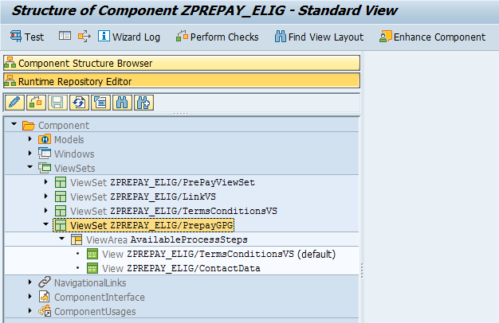

- Go to component structure browser->Windows->ZPREPAY_ELIG/ECInboundWindow.
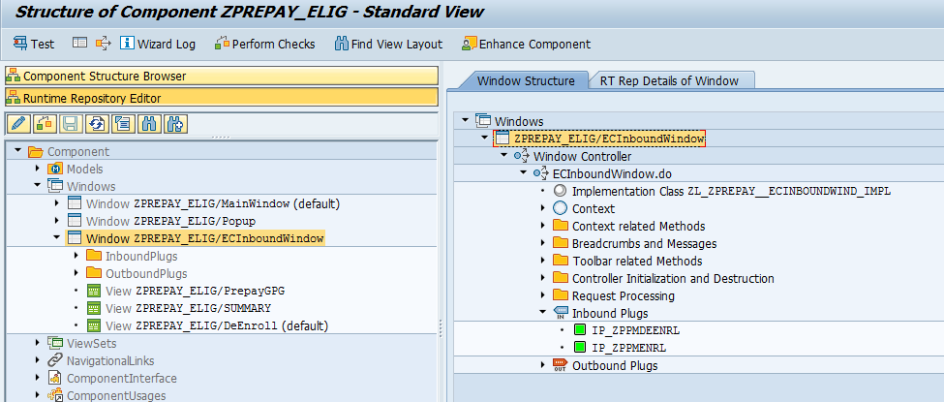
- Go to the Inbound Plugs IP_ZPPMENRL.
DATA: lr_current TYPE REF TO if_bol_bo_property_access,
ls_msgattr TYPE zspgmmsg_attr.
DATA: ls_msg TYPE zsppm_eligibility.
IF iv_collection IS BOUND.
lr_current ?= iv_collection->get_first( ).
CLEAR: gt_brf_msg, gt_msg.
WHILE lr_current IS BOUND.
* Get Properties
lr_current->get_properties(
IMPORTING
es_attributes = ls_msgattr ).
APPEND ls_msgattr TO gt_brf_msg.
IF ls_msgattr-type = 'W'.
ls_msg-partner = ls_msgattr-zenrlbp.
ls_msg-buag = ls_msgattr-zenrlca.
ls_msg-zpgm_type = ls_msgattr-field.
ls_msg-zstatus = ls_msgattr-type.
ls_msg-zmessage = ls_msgattr-message.
APPEND ls_msg TO gt_msg.
ENDIF.
lr_current ?= iv_collection->get_next( ).
ENDWHILE.
ENDIF.
DATA: lv_available TYPE boolean,
lv_error TYPE flag.
DATA: lr_msg_srv TYPE REF TO cl_bsp_wd_message_service.
lr_msg_srv = cl_bsp_wd_message_service=>get_instance( ).
* Get the RFC destination
cl_crm_isu_il_tools=>get_backend_dest(
EXPORTING
iv_check_avlbl = abap_true
IMPORTING
ev_backend_dest = zl_zprepay__ecinboundwind_impl=>gv_dest
ev_available = lv_available
EXCEPTIONS
no_backend_dest = 1
OTHERS = 2 ).
IF sy-subrc <> 0 OR lv_available IS INITIAL.
CLEAR zl_zprepay__ecinboundwind_impl=>gv_dest.
lv_error = 'X'.
CALL METHOD lr_msg_srv->add_message
EXPORTING
iv_msg_type = if_genil_message_container=>mt_error
iv_msg_id = 'ZFO_CRM'
iv_msg_number = '019'.
ENDIF.
* Get the confirmed Buag/BP
DATA: lo_bdc TYPE REF TO if_crm_ui_data_context,
lo_buag TYPE REF TO if_bol_bo_property_access,
lo_bp TYPE REF TO if_bol_bo_property_access,
ls_buag TYPE crmt_buag_ic_attr,
ls_bp TYPE crmst_header_object_buil.
TRY.
lo_bdc = cl_crm_ui_data_context_srv=>get_instance( ).
CHECK lo_bdc IS BOUND.
lo_buag = lo_bdc->get_entity( 'CURRENTBUAG' ).
IF lo_buag IS BOUND.
* Get confirmed Business Agreement details
lo_buag->get_properties( IMPORTING es_attributes = ls_buag ).
zl_zprepay__ecinboundwind_impl=>gv_buag = ls_buag-buag_id.
zl_zprepay__ecinboundwind_impl=>gv_bupa = ls_buag-bupa_id.
ELSE.
lo_bp = lo_bdc->get_entity( 'CURRENTCUSTOMER' ).
* Get BP details
lo_bp->get_properties( IMPORTING es_attributes = ls_bp ).
zl_zprepay__ecinboundwind_impl=>gv_bupa = ls_bp-bp_number.
ENDIF.
CATCH cx_root.
ENDTRY.
IF zl_zprepay__ecinboundwind_impl=>gv_bupa IS INITIAL OR
zl_zprepay__ecinboundwind_impl=>gv_buag IS INITIAL.
lv_error = 'X'.
CALL METHOD lr_msg_srv->add_message
EXPORTING
iv_msg_type = 'E'
iv_msg_id = 'ZFO_CRM'
iv_msg_number = '020'.
ENDIF.
* Navigate back to IUICOBJD
IF lv_error = 'X'.
DATA: lv_navigation TYPE REF TO if_crm_ui_navigation_service,
ev_linkid TYPE string VALUE 'UTL-ID-WC'.
lv_navigation = cl_crm_ui_navigation_service=>get_instance( me ).
lv_navigation->navigate( ev_linkid ).
ELSE.
* Navigate to Error View
view_manager->navigate( source_rep_view = me->rep_view
outbound_plug = 'Navigate_To_Enroll' ).
ENDIF.
ENDMETHOD.
- Here we will call the method for PrePay enrollment Guided Process with the terms and conditions for the customer and the confirmed business agreement.
- In this process of calling if any error occurs then we are navigating back to the identification screen.
- The guided page ZPREPAY_ELIG/PrepayGPG has 2 views linked to it ZPREPAY_ELIG/TermsConditionsVS and ZPREPAY_ELIG/ContactData.
- ZPREPAY_ELIG/TermsConditionsVS will have 3 views embedded in to it.
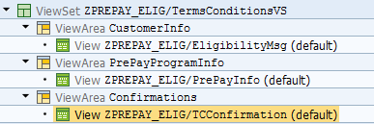
- View ZPREPAY_ELIG/TCConfirmation will have a “CANCEL” button. Which will allow you to cancel the process while you are in the screen.
METHOD eh_oncancel.
DATA: lr_msg_srv TYPE REF TO cl_bsp_wd_message_service.
DATA: lr_navigation TYPE REF TO if_crm_ui_navigation_service.
lr_msg_srv = cl_bsp_wd_message_service=>get_instance( ).
CALL METHOD lr_msg_srv->add_message
EXPORTING
iv_msg_type = 'S'
iv_msg_id = 'ZFO_CRM'
iv_msg_number = '007'.
op_default_back( ).
ENDMETHOD.
- The next screen in guided page is contact data it will have 2 buttons “Submit” and “Cancel”. If you click cancel it will cancel the process and take you to identification screen. If you click Submit it will complete the enrollment process and takes you to Summary Screen ZPREPAY_ELIG/SUMMARY.
- Clicking on Submit will trigger a Workflow in ECC to complete the enrollment process and also creates an Interaction Record in CRM.
METHOD eh_onsubmit.
DATA: lr_msg_srv TYPE REF TO cl_bsp_wd_message_service.
DATA: lv_invalid TYPE char1.
DATA: lr_contact TYPE REF TO if_bol_bo_property_access.
DATA: lv_email TYPE string,
lv_channel TYPE string,
lv_prefcomm TYPE char6,
lv_prradio TYPE char1.
lr_msg_srv = cl_bsp_wd_message_service=>get_instance( ).
lr_contact ?= me->typed_context->contact->collection_wrapper->get_current( ).
lv_email = lr_contact->get_property_as_string( iv_attr_name = 'EMAIL' ).
lv_channel = lr_contact->get_property_as_string( iv_attr_name = 'PREFCOMM' ).
lv_prradio = lr_contact->get_property_as_string( iv_attr_name = 'PREFCOMUNICATION' ).
IF lv_prradio = '1'.
lv_prefcomm = 'E_MAIL'.
ELSEIF lv_prradio = '2'.
lv_prefcomm = 'IVR'.
ELSEIF lv_prradio = '3'.
lv_prefcomm = 'SMS'.
ENDIF.
CALL METHOD zl_zprepay__contactdata_impl=>contact_validation
EXPORTING
iv_email = lv_email
iv_prefcomm = lv_channel
iv_prradio = lv_prradio
IMPORTING
ov_invalid = lv_invalid.
IF lv_invalid IS INITIAL.
IF zl_zprepay__ecinboundwind_impl=>gv_dest IS NOT INITIAL.
* Trigger WF event
CONSTANTS: c_zisuaccnt TYPE swo_objtyp VALUE 'ZISUACCNT',
c_zppmenroll TYPE swo_event VALUE 'zppmenroll',
c_commit TYPE flag VALUE 'X'.
DATA: lt_container TYPE TABLE OF swr_cont,
lw_container TYPE swr_cont,
lv_objkey TYPE swo_typeid.
zl_zprepay__contactdata_impl=>gv_email = lv_email.
lw_container-element = 'EnrollmentReqDate'.
lw_container-value = sy-datum.
APPEND lw_container TO lt_container.
lw_container-element = 'PreferredCommMethod'.
lw_container-value = lv_prefcomm.
APPEND lw_container TO lt_container.
lw_container-element = 'PreferredCommChannel'.
lw_container-value = lv_channel.
APPEND lw_container TO lt_container.
lw_container-element = 'CriticalCommMethod'.
lw_container-value = 'E_MAIL'.
APPEND lw_container TO lt_container.
lw_container-element = 'CriticalCommChannel'.
lw_container-value = lv_email.
APPEND lw_container TO lt_container.
lw_container-element = 'CreatedBy'.
lw_container-value = sy-uname.
APPEND lw_container TO lt_container.
lv_objkey = zl_zprepay__ecinboundwind_impl=>gv_buag.
CALL FUNCTION 'SAP_WAPI_CREATE_EVENT'
DESTINATION zl_zprepay__ecinboundwind_impl=>gv_dest
EXPORTING
object_type = c_zisuaccnt
object_key = lv_objkey
event = c_zppmenroll
commit_work = c_commit
TABLES
input_container = lt_container.
IF sy-subrc <> 0.
CALL METHOD lr_msg_srv->add_message
EXPORTING
iv_msg_type = 'S'
iv_msg_id = 'ZFO_CRM'
iv_msg_number = '005'.
ELSE.
COMMIT WORK.
CALL METHOD lr_msg_srv->add_message
EXPORTING
iv_msg_type = 'S'
iv_msg_id = 'ZFO_CRM'
iv_msg_number = '004'.
ENDIF.
ENDIF.
* Create IRec
DATA: lv_text TYPE string,
lv_ir_created TYPE boole_d,
lv_ir_number TYPE crmt_object_id_db.
CONCATENATE 'Contract '
zl_zprepay__ecinboundwind_impl=>gv_buag
'; PrePay Enrollment Pending from '
sy-datum
'; Caller Name '
zl_zprepay__ecinboundwind_impl=>gv_bupa
INTO lv_text.
CALL FUNCTION 'Z_SE_IR_CREATE'
EXPORTING
i_bp = zl_zprepay__ecinboundwind_impl=>gv_bupa
i_app_id = 'SE_PPM_PENDING' "PrePay Enrollment Pending
i_text = lv_text
i_buag = zl_zprepay__ecinboundwind_impl=>gv_buag
IMPORTING
ir_created = lv_ir_created
ir_number = lv_ir_number
EXCEPTIONS
ir_not_created = 1
no_bp_passed = 2
no_business_agreement = 3
no_confirmed_bp = 4
no_application_id = 5
bus_agr_rel_error = 6
bus_agr_set_notfound = 7
OTHERS = 8.
IF sy-subrc = 0.
CALL METHOD lr_msg_srv->add_message
EXPORTING
iv_msg_type = 'S'
iv_msg_id = 'ZFO_CRM'
iv_msg_number = '006'.
ENDIF.
* Navigate to Summary Screen
CALL METHOD op_to_summary.
ENDIF.
finish( ).
ENDMETHOD.
- ZPREPAY_ELIG/SUMMARY screen will have a “Done” button, upon clicking it will take you to Identification screen.
- The De-Enrollment process will be triggered from the window ZPREPAY_ELIG/ECInboundWindow inbound plug IP_DEENRL when the call comes from the enrollment center to process PrePay De-enrollment.
- In the de-enrollment process first it will raise a De-enrollment confirmation popup. This is view popup window.
* Show Popup
FREE gr_popup.
* Open De-enrollment confrimation pop-up
gr_popup ?= comp_controller->window_manager->create_popup(
iv_interface_view_name = 'ZPREPAY_ELIG/Popup' iv_usage_name = 'contactusage'
iv_title = 'De-Enrollment Confirmation POPUP' ).
gr_popup->set_display_mode( if_bsp_wd_popup=>c_display_mode_surrounded ).
gr_popup->set_on_close_event( iv_event_name = 'DEPOPUP_CLOSED'
iv_view = me ). "#EC NOTEXT
gr_popup->set_window_height( iv_height = 300 ).
gr_popup->set_window_width( iv_width = 600 ).
gr_popup->open( ).
This screen popup screen ZPREPAY_ELIG/DeEnrollPopup is linked to a window ZPREPAY_ELIG/Popup.
- In the popup screen ZPREPAY_ELIG/DeEnrollPopup you have 2 buttons “Yes” and “No”.
- If you click No it will take you to Identification screen. If you click Yes it will process the de-enrollment by triggering the Workflow and creates an interaction record and then navigates to identification screen.
METHOD process_deenrollment.
DATA: lv_navigation TYPE REF TO if_crm_ui_navigation_service,
ev_linkid TYPE string VALUE 'UTL-ID-WC'.
DATA: lr_msg_srv TYPE REF TO cl_bsp_wd_message_service.
lv_navigation = cl_crm_ui_navigation_service=>get_instance( me ).
lr_msg_srv = cl_bsp_wd_message_service=>get_instance( ).
IF zl_zprepay__ecinboundwind_impl=>gv_dest IS NOT INITIAL.
* Trigger WF event
CONSTANTS: c_zisuaccnt TYPE swo_objtyp VALUE 'ZISUACCNT',
c_zppmdeenroll TYPE swo_event VALUE 'ZPPMDEENROLL',
c_commit TYPE flag VALUE 'X'.
DATA: lt_container TYPE TABLE OF swr_cont,
lw_container TYPE swr_cont,
lv_objkey TYPE swo_typeid.
lw_container-element = 'DeEnrollmentDate'.
lw_container-value = sy-datum.
APPEND lw_container TO lt_container.
lw_container-element = 'CreatedBy'.
lw_container-value = sy-uname.
APPEND lw_container TO lt_container.
lw_container-element = 'DeEnrollmentReason'.
lw_container-value = '03'.
APPEND lw_container TO lt_container.
lv_objkey = zl_zprepay__ecinboundwind_impl=>gv_buag.
CALL FUNCTION 'SAP_WAPI_CREATE_EVENT'
DESTINATION zl_zprepay__ecinboundwind_impl=>gv_dest
EXPORTING
object_type = c_zisuaccnt
object_key = lv_objkey
event = c_zppmdeenroll
commit_work = c_commit
TABLES
input_container = lt_container.
IF sy-subrc <> 0.
CALL METHOD lr_msg_srv->add_message
EXPORTING
iv_msg_type = 'E'
iv_msg_id = 'ZFO_CRM'
iv_msg_number = '003'.
op_default_back( ).
ELSE.
COMMIT WORK.
CALL METHOD lr_msg_srv->add_message
EXPORTING
iv_msg_type = 'S'
iv_msg_id = 'ZFO_CRM'
iv_msg_number = '002'.
ENDIF.
ENDIF.
* create IRec
DATA: lv_text TYPE string,
lv_ir_created TYPE boole_d,
lv_ir_number TYPE crmt_object_id_db.
CONCATENATE 'Contract '
zl_zprepay__ecinboundwind_impl=>gv_buag
'; PrePay De-enrollment Pending on '
sy-datum
'; Caller Name '
zl_zprepay__ecinboundwind_impl=>gv_bupa
INTO lv_text.
CALL FUNCTION 'Z_SE_IR_CREATE'
EXPORTING
i_bp = zl_zprepay__ecinboundwind_impl=>gv_bupa
i_app_id = 'SE_PPM_DNRL_PND'
i_text = lv_text
i_buag = zl_zprepay__ecinboundwind_impl=>gv_buag
IMPORTING
ir_created = lv_ir_created
ir_number = lv_ir_number
EXCEPTIONS
ir_not_created = 1
no_bp_passed = 2
no_business_agreement = 3
no_confirmed_bp = 4
no_application_id = 5
bus_agr_rel_error = 6
bus_agr_set_notfound = 7
OTHERS = 8.
IF sy-subrc = 0.
CALL METHOD lr_msg_srv->add_message
EXPORTING
iv_msg_type = 'S'
iv_msg_id = 'ZFO_CRM'
iv_msg_number = '009'. " '001'.
ENDIF.
* Navigate to Identification
lv_navigation->navigate( ev_linkid ).
ENDMETHOD.

System Diagram
Technical Parts Inventory
-------Name------- | ----Description---- | -----Location----- | ----Environment---
ZPREPAY_ELIG | Component |  | C3D
ZCL_PPM_THTMLB_FORM_ITERATOR | Class |  | C3D
ZPPM_ACCTBALANCE_RFC | Function Module |  | E2D
ZTT_CA_PGMTYP | Table Type |  | C3D
ZSPGM_BRF_INPUT | Structure |  | C3D
ZSPPM_BRF_RETURN | Structure |  | C3D
ZSPPM_CA_PGMTYPE | Structure |  | C3D
ZSPPM_ELIGIBILITY | Structure |  | C3D
ZSPPM_SUMMARY | Structure |  | C3D
ZSPPM_TEXT | Structure |  | C3D
ZINSTALLATION | Data Element |  | C3D
ZPGM | Data Element |  | C3D
ZPGMTYPE | Data Element |  | C3D

Dependent Parts Inventory
-------Name------- | ----Description--- | -----Location----- | ----Environment---
N/A | N/A | N/A | N/A

